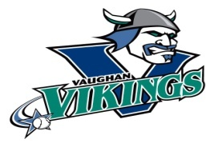

**VIKINGS DEVELOPMENT PROGRAM**

The ***Vikings Development Program*** is a comprehensive off-season elite training program structured for players looking to develop their skills and take their game to the next level. It is designed to mirror the Vikings HPP off-season training and development program

The 20-week fall, and winter program is available to Viking players born between 2012 and 2014 (Select, A or AA level) and those born in 2015 (AAA/AA level).

The program will focus on developing all aspects of the game including hitting, throwing and arm care, defensive skills and baserunning. Players will receive coaching and training from Viking HPP instructors.

***Program Schedule & Features:***

*Number of Weeks:* 20

*Training Period:* November 21, 2025 - *April* 29, 2026

*Hours per Week:* 4.5

*Dates/Times:*

*Hitting: Wednesdays (6-7:30 pm) Starting Nov. 19*

***OR***

*Fridays (6-7:30 pm) Starting Nov. 21*

*Skill Development: Saturdays (2-4 pm) Starting Nov. 22*

*Pitching: Sundays (8-9:15 am* ***or*** *9-10:15 am) Starting Nov. 23*

*Cost: $3,000*

***Questions/Information:*** [double.d@rogers.com](mailto:double.d@rogers.com)

***Registration:*** [info@vaughanvikings.com](mailto:info@vaughanvikings.com) or (905-832-9659)

***Join the Vikings Development Program and develop the tools to excel at the next level!***